Why should a company perform drug testing?
ANSWER: According to the 2002 National Household Survey on Drug Abuse approximately:
- 19.5 million Americans or 8.3 % admit to current (in the last 30 days)of illicit drug use;
- 54 million (22 .9% ) of Americans participated in binge drinking and 15.9 million adults admit to "heavy" drinking (5 or more drinks on at least 5 or more occasions in the past month); and
- 1 in 7 Americans (14.2 % or 33.5 million persons) drove under the influence of alcohol in 2002.¹
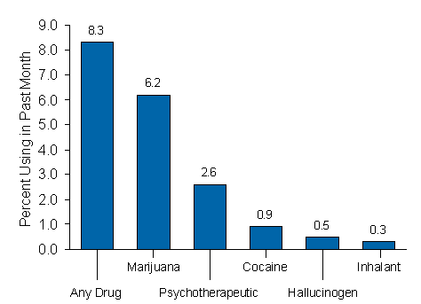

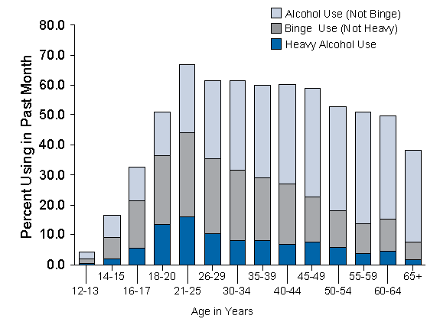
ANSWER: The Majority of Drug Users are Employed
According to the government's annual Household Survey on Drug Abuse in America in 2002, about three-quarters (74.6%) of all illicit drug users 18 and older are employed full or part time… that's approximately 16.6% of the working population.¹
ANSWER: Drug Users Are Not The Best Employees
The federal government reported that drug abusing employees, when compared to non-using workers, are:
- Not staying in a job very long (High Turnover)
- Not showing up for work (High Absenteeism)
- Less productive employees (Poor Job Performance)
- More likely to be involved in a workplace accident and
- More likely to file a workers' compensation claim.
ANSWER: Drug Users are Unsafe to their Co-Workers
The National Safety Council reports that 80 percent of those injured in "serious" drug-related accidents at work are not the drug abusing employees but non-using co-workers and others.²
ANSWER: Drug Users are Very Costly to Employ
How much does drug abuse cost employers? The U.S. Navy estimates each drug user costs his or her employer an average of $6,600 annually more than non-substance abusing co-workers.²
ANSWER: Drug Testing Saves Money
The U.S. Navy claims that its drug-free workplace program, which includes random drug testing and costs approximately $20 million a year, has reduced the number of sailors who use drugs and abuse alcohol by more than 57 percent. That equates to a savings of more than $210 million every year. In other words, the Navy claims it realizes a savings of approximately $10 for every dollar it spends on drug testing.²
TRY THIS TWO-STEP FORUMULA TO CALCULATE YOUR "RETURN ON INVESTMENT" (ROI) IN DRUG TESTING AND SEE HOW MUCH YOU CAN SAVE!
STEP 1: Multiply the number of employees at your company by percentage your think have a substance abuse problem; then multiply that number by the average cost per year for each drug abuser on your payroll to determine the cost of substance at your company.²
__________________ | % of your workforce that uses drugs (national average is about 17%)
X ________________ | Multiplied by the total number of employees at your company
X ________________ | Multiplied by the Average cost per year for each drug abuser (national average is $6,600)
= $_______________ | Cost of substance abuse at your company
STEP 2: Subtract the total amount that you pay for drug testing each year from the answer you just got calculating the cost of substance abuse at your company.
__________________ | Cost of substance abuse at your company
-
__________________ | Cost of drug testing at your company
= $_______________ | This figure represents your return on investment(ROI) with drug testing.

- Substance Abuse and Mental Health Services Administration. 2003 National Household Survey on Drug Use and Health: National Findings. Office of Applied Studies, NHSDA Series H-22, DHHS Publication No. SMA 03-3836. Rockville, MD.
- Current, WF. In favor of a drug-free workplace: Why Drug Testing?. Coral Springs, FL; 1999.

